Milestone 1: Define Problem / Problem Understanding Activity 1: Specify the business problem Refer Project Description Activity 2: Business requirements A business requirement for a comprehensive crash analysis of The Tragedy of Flight would likely include the following elements:

● Detailed information about the crash, including the date, time, location, and weather conditions at the time of the incident.

● A thorough analysis of the events leading up to the crash, including any mechanical failures or human errors that may have contributed to the incident.

● A review of the flight data and cockpit voice recordings to gather additional information about the events leading up to the crash.

● Interviews with the flight crew, passengers, and any witnesses to the crash to gather additional information about the incident. Activity 3: Literature Survey (Student Will Write) A literature survey is a method of researching existing literature and studies related to a specific topic. In the context of analysing the airplane crash, a literature survey would involve reviewing studies and articles that have been published on the topic of airplane crash, as well as studies specific to crash analysis. The literature survey would include sources such as academic journals, industry reports, and online articles. The literature survey would also explore any existing research on airplane crash, and would aim to identify any unique challenges or opportunities that to overcome crash. Activity 4: Social and Business Impact. Social Impact: The analysis can provide closure to the families and loved ones of the victims of the crash, as well as to the broader public. It can also help to improve public confidence in the aviation industry by identifying and addressing any safety issues that may have contributed to the incident. Business Impact: The analysis can have significant business implications for the airline and aircraft manufacturer involved in the incident. If the analysis finds that the crash was caused by mechanical or design issues, the manufacturer may be liable for damages and may face significant financial losses. The airline may also face legal claims and reputational damage.

Milestone 2: Data Collection & Extraction from Database

Data collection is the process of gathering and measuring information on variables of interest, in an established systematic fashion that enables one to answer stated research questions, test hypotheses, and evaluate outcomes and generate insights from the data.

Activity 1: Collect the dataset 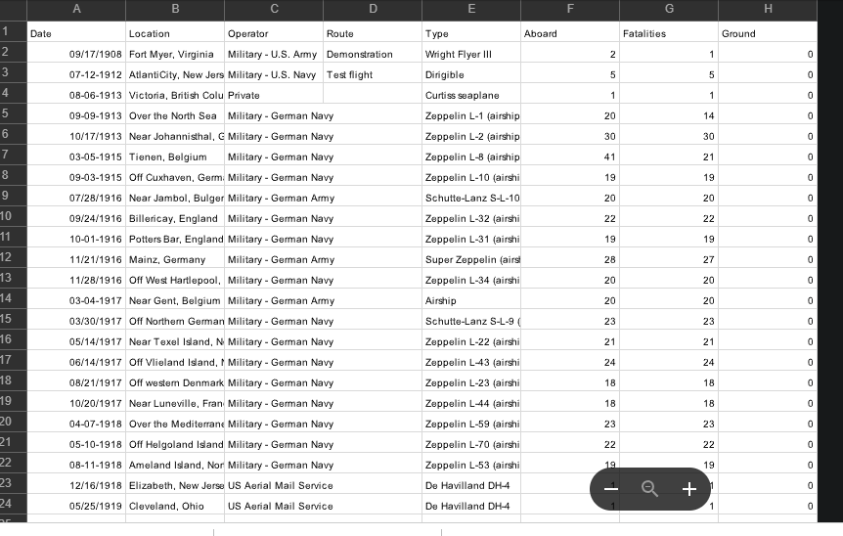

Activity 1.1: Understand the data

Data contains all the meta information regarding the columns described in the CSV files. we have provided 8 CSV files:

1. Date

2. Location

3. Operators

4. Route

5. Type

6. Aboard

7. Fatalities

8. Ground

Column Description for Date:

1. date: This column represents the dates.

2. Location:

This column represents the accident locations.

3. Operators: This column represents the accidents which made by operators.

4. Route: This column represents the airplane route

. 5. Type: This column represents the airplane type.

6. Aboard: This column represents the count of people aboard.

7. Fatalities: This column represents the count of death.

8. Ground: This column represents the count of people grounded.

Activity 2: Storing Data in DB & Perform SQL Operations

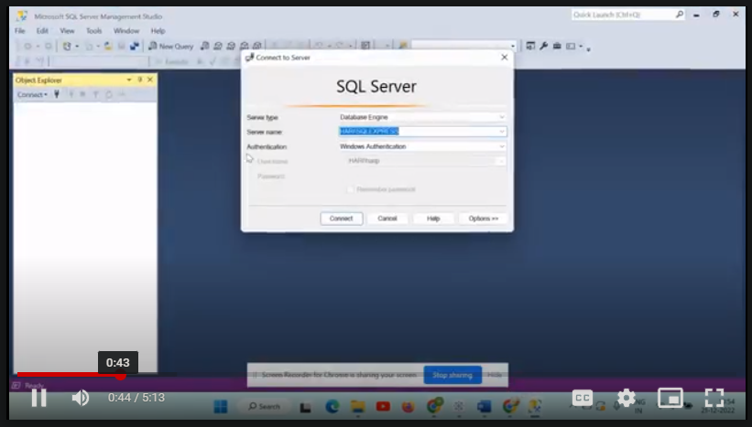

Activity 3: Connect DB with Tableau

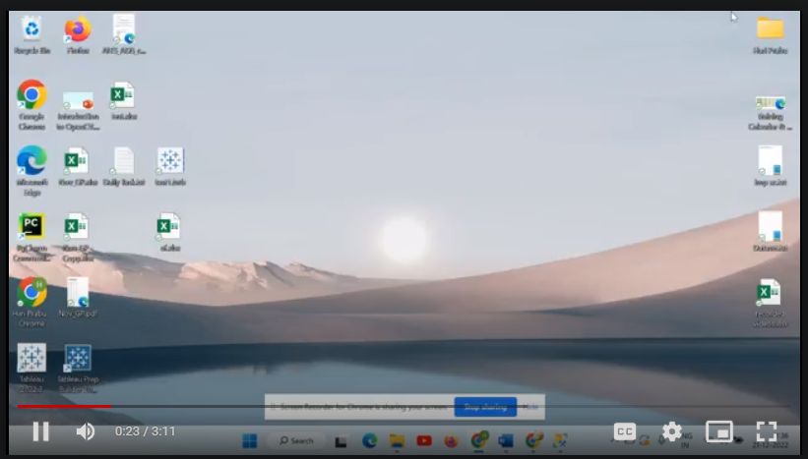

Milestone 3: Data Preparation

Activity 1: Prepare the Data for Visualization (Refer this video to understand about data preparation)

Preparing the data for visualization involves cleaning the data to remove irrelevant or missing data, transforming the data into a format that can be easily visualized, exploring the data to identify patterns and trends, filtering the data to focus on specific subsets of data, preparing the data for visualization software, and ensuring the data is accurate and complete. This process helps to make the data easily understandable and ready for creating visualizations to gain insights into the performance and efficiency

Explanation video link 1:

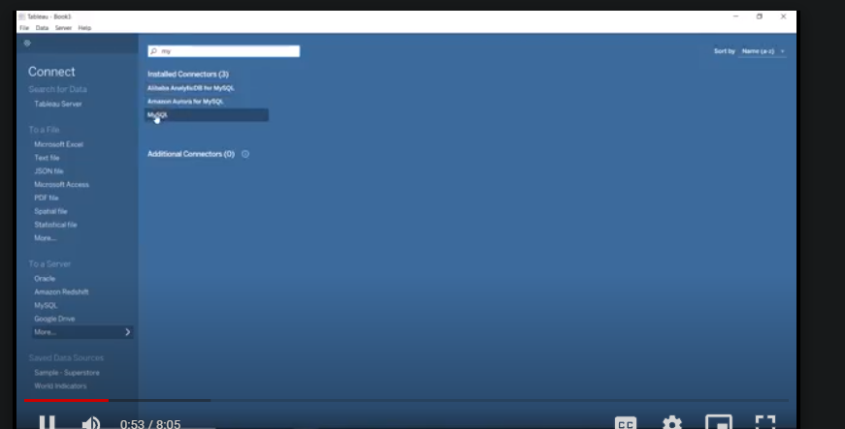

Explanation video link 2:

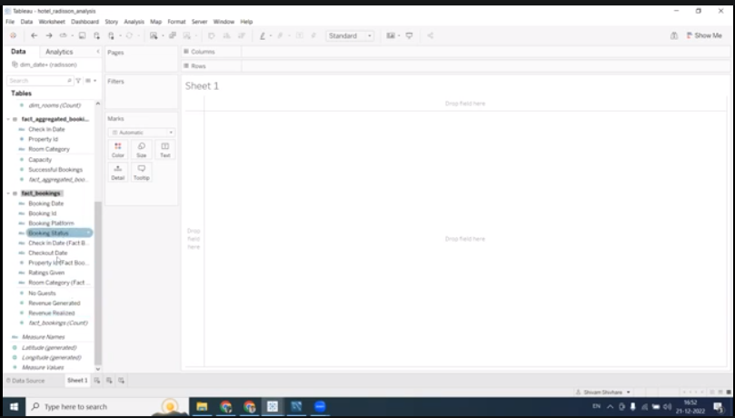

Milestone 4: Data Visualization

Data visualization is the process of creating graphical representations of data in order to help people understand and explore the information. The goal of data visualization is to make complex data sets more accessible, intuitive, and easier to interpret. By using visual elements such as charts, graphs, and maps, data visualizations can help people quickly identify patterns, trends, and outliers in the data.

Activity 1: Comparing Aboard vs Fatalities vs Ground

Explanation video :

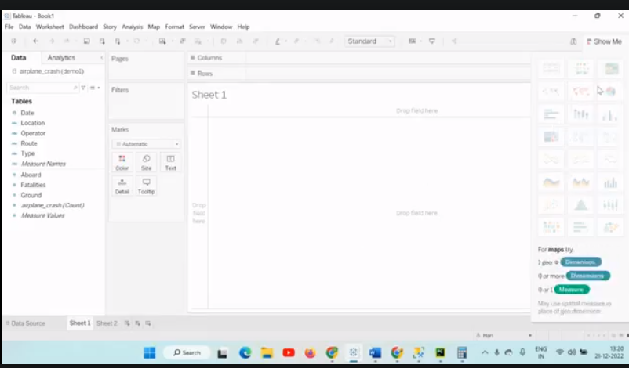

Activity 2: Max accidents based on years

Explanation video: 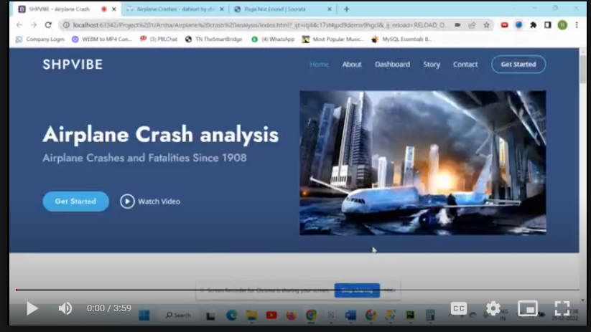

Activity 3: Accidents happened in 1972 (MAX ACCIDENTS) based on months Explanation video: 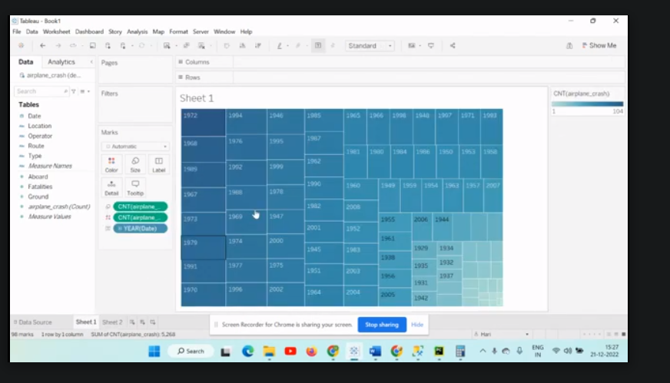

Activity 4: Highest No. of accident happened by Operators Explanation video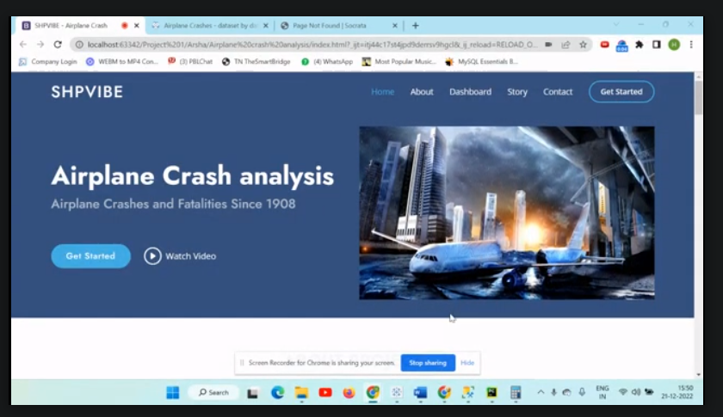

Activity 6: Top 3 flights which have max accident history

Explanation video:

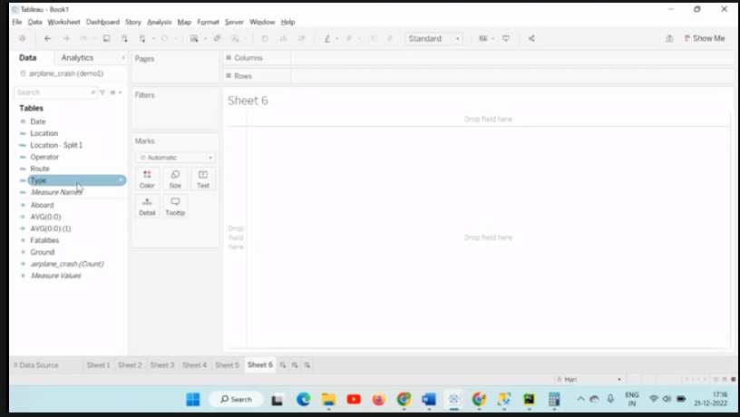

Activity 7: Accidents ba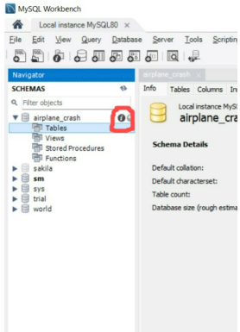sed on regions

Explanation video: 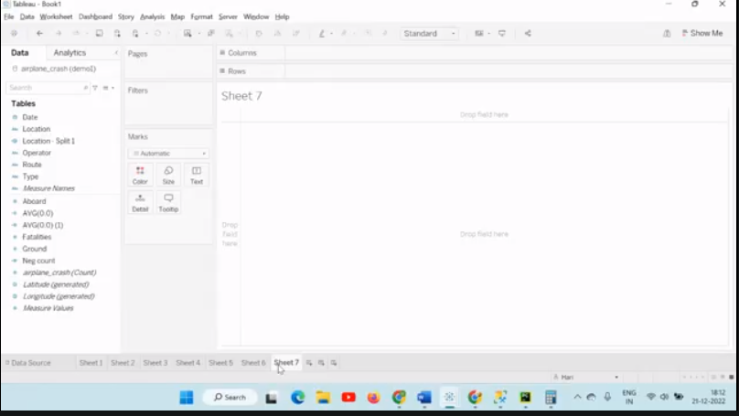

Milestone 5: Dashboard

A dashboard is a graphical user interface (GUI) that displays information and data in an organized, easy-to-read format. Dashboards are often used to provide real-time monitoring and analysis of data, and are typically designed for a specific purpose or use case. Dashboards can be used in a variety of settings, such as business, finance, manufacturing, healthcare, and many other industries. They can be used to track key performance indicators (KPIs), monitor performance metrics, and display data in the form of charts, graphs, and tables.

Activity :1- Responsive and Design of Dashboard

Explanation video:

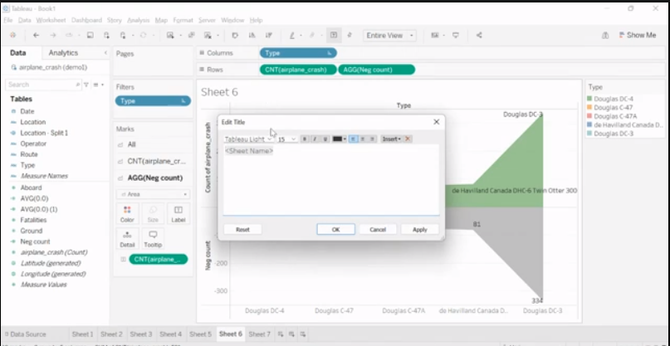

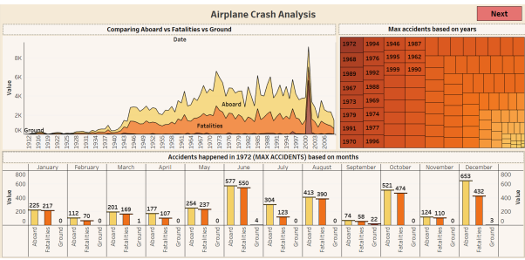

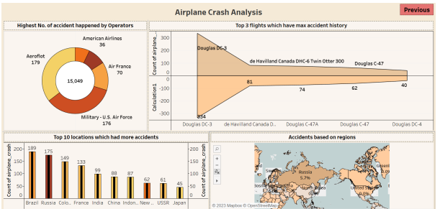

Milestone 6: Story

A data story is a way of presenting data and analysis in a narrative format, with the goal of making the information more engaging and easier to understand. A data story typically includes a clear introduction that sets the stage and explains the context for the data, a body that presents the data and analysis in a logical and systematic way, and a conclusion that summarizes the key findings and highlights their implications. Data stories can be told using a variety of mediums, such as reports, presentations, interactive visualizations, and videos.

Activity:1- No of Scenes of Story

Explanation video:

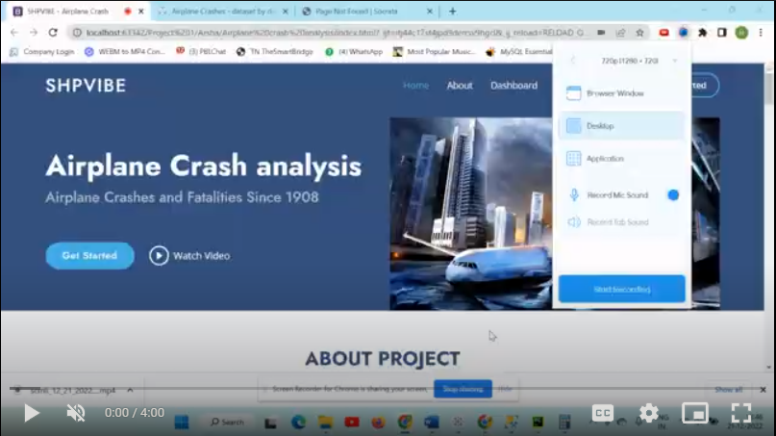

STORY 01

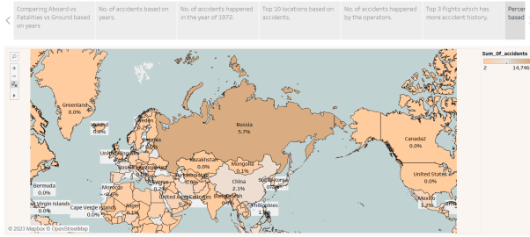

Milestone 7: Performance Testing

Activity 1: Amount of Data Rendered to DB

● The amount of data that is rendered to a database depends on the size of the dataset and the capacity of the database to store and retrieve data.

● Open the MySQL Workbench, go to the database then click to expand the tables,select the table and click on (i) button to get the information related to table such as column count,table rows etc.



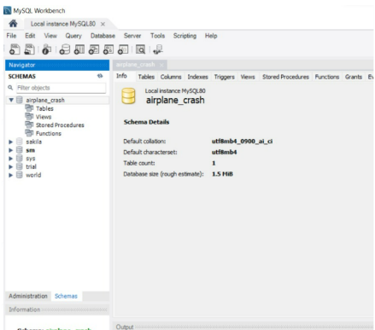

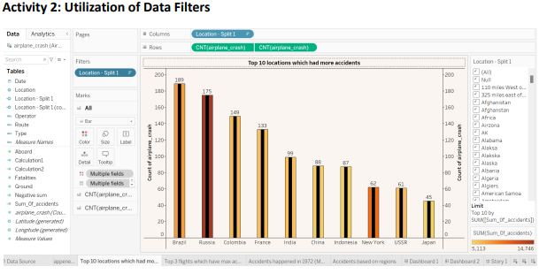

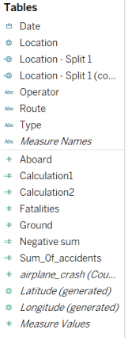

Activity 4: No of Visualizations/ Graphs

1. Comparing Aboard vs Fatalities vs Ground

2. Max accidents based on years

3. Accidents happened in 1972 (MAX ACCIDENTS) based on months

4. Highest No. of accident happened by Operators 5. Top 10 locations which had more accidents

6. Top 3 flights which have max accident history

7. Accidents based on regions

Milestone 8: Web integration

Publishing helps us to track and monitor key performance metrics, to communicate results and progress. help a publisher stay informed, make better decisions, and communicate their performance to others.

Publishing dashboard and reports to tableau public

Step 1: Go to Dashboard/story, click on share button on the top ribbon

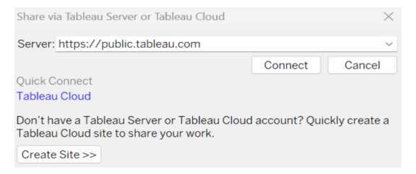

Give the server address of your tableau public account and click on connect.

Step 2: Once you click on connect it will ask you for tableau public user name and password



Once you login into your tableau public using the credentials, the particular visualization will be published into tableau public

Note: While publishing the visualization to the public, the respective sheet will get published when you click on share option.

Activity 1: Dashboard and Story embed with UI With Flask

Explanation video

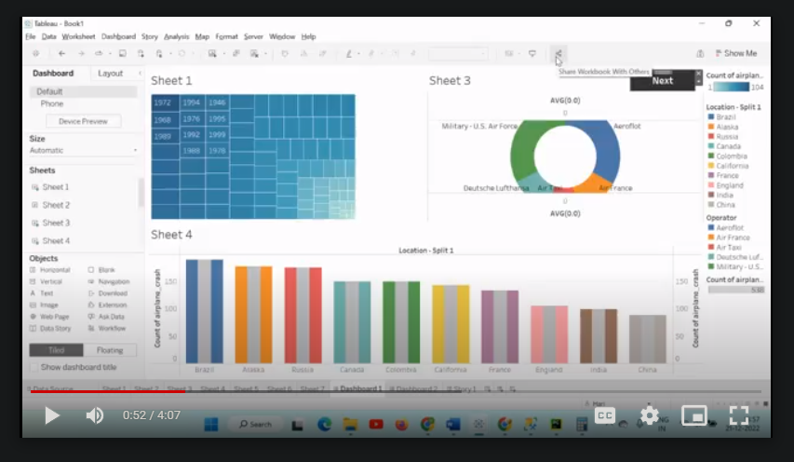

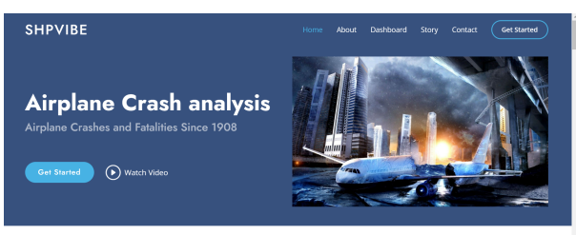

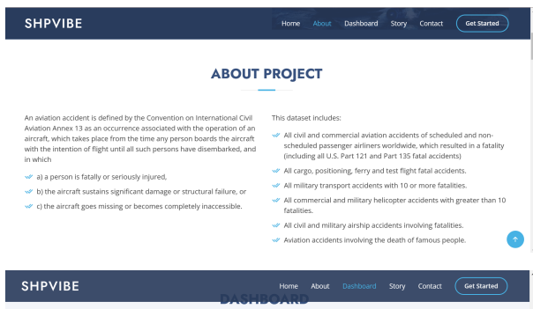

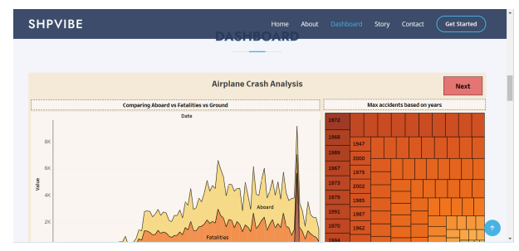

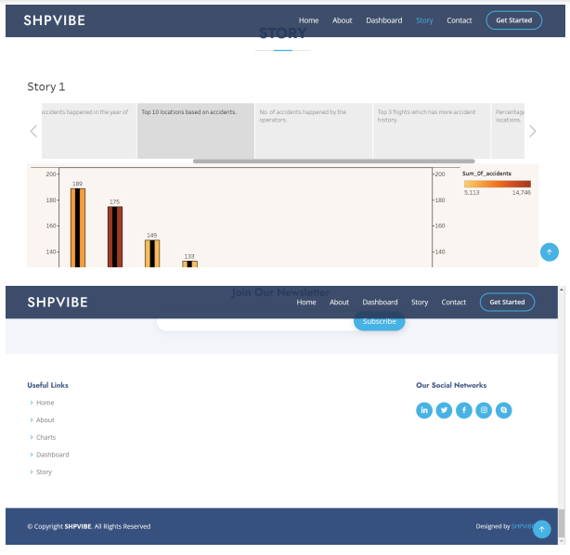

Milestone 9: Project Demonstration & Documentation

Below mentioned deliverables to be submitted along with other deliverables

Activity 1:- Record explanation Video for project end to end solution

Activity 2:- Project Documentation-Step by step project development procedure

Create document as per the template provided